**Lab 2 (Day-10)**

**1.Use student table created in previous lab and**

**create another table Courses with the following columns:**

**CourseID (Integer, Primary Key)**

**CourseName (VARCHAR, Not Null)**

**StudentID (Integer, Foreign Key referencing Students(StudentID))**

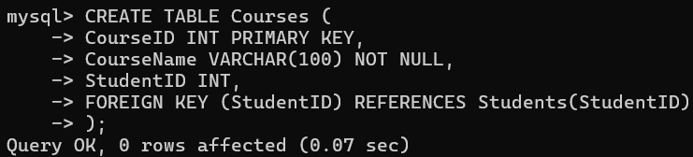

**2.Insert three records into the Students table with sample data.**

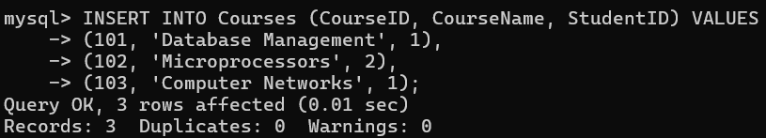

**3.Write an SQL query to display Student Name, Course Name for all students who have enrolled in a course using an INNER JOIN.**

